11. Implementation of Autowiring using XML / Annotations
You can use both:
- applicationContext.xml (XML autowiring)
- Annotations (@Autowired, @Component, etc.)
Spring supports mixed configuration.

Concept | Meaning | Spring Annotation
IoC | Spring controls object creation | (Internal)
DI | Injection of dependencies | @Autowired
Autowiring | Automatic DI process | @Autowired
Bean | Object managed by Spring | @Component, @Service

Aspect | XML Autowiring | Annotation Autowiring
Configuration | XML | Java annotations
Injection | Setter | Field
Bean creation | <bean> | @Component
Autowire | autowire="byType" | @Autowired

SINGLE PROJECT: AUTOWIRING (XML + ANNOTATIONS)

Create Project In Eclipse / STS
File → New → Maven Project
✔ Create a simple project
Group Id : com.klu
Artifact Id : spring-autowire-demo
Packaging : jar

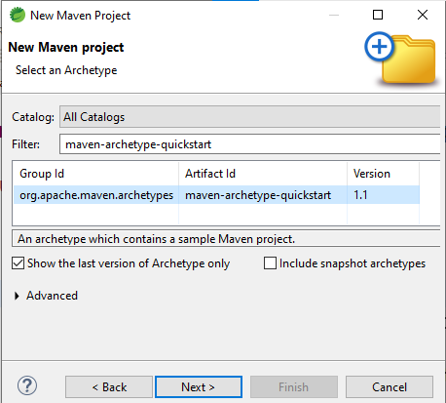
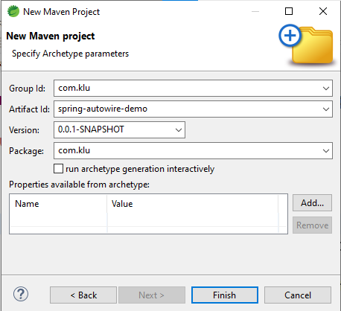

Create the following Project Structure
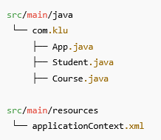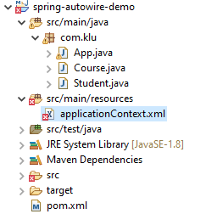

Create a resources folder in side a src/main folder as follows: Right click on src/main/java -> new -> folder
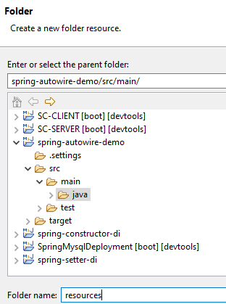

Add Spring Dependency (pom.xml)

------------------------------------------------
<dependency>
<groupId>org.springframework</groupId>
<artifactId>spring-context</artifactId>
<version>6.1.4</version>
</dependency>
================================================================

PART A: AUTOWIRING USING XML
======================================

Course.java (NO annotations)

---------------------------------------------
package com.klu;

public class Course {

private String courseName = "Autowiring using Spring Framework (XML)";

public String getCourseName() {
return courseName;
}
}

Student.java (Setter for XML Autowiring)

---------------------------------------------------------------
package com.klu;

public class Student {

private Course course;

//Setter is REQUIRED for XML autowiring
public void setCourse(Course course) {
this.course = course;
}

public void display() {
System.out.println("Course: " + course.getCourseName());
}
}

applicationContext.xml (XML Autowiring)
📁 src/main/resources/applicationContext.xml
----------------------------------------------------------
<beans xmlns="http://www.springframework.org/schema/beans"
xmlns:xsi="http://www.w3.org/2001/XMLSchema-instance"
xsi:schemaLocation="
http://www.springframework.org/schema/beans
https://www.springframework.org/schema/beans/spring-beans.xsd">

<bean id="course" class="com.klu.Course"/>

<!-- XML Autowiring -->
<bean id="student" class="com.klu.Student" autowire="byType"/>

</beans>

App.java

----------
package com.klu;

import org.springframework.context.ApplicationContext;
import org.springframework.context.support.ClassPathXmlApplicationContext;

public class App {

public static void main(String[] args) {

ApplicationContext context =
new ClassPathXmlApplicationContext("applicationContext.xml");

Student student = context.getBean(Student.class);
student.display();
}
}

Run the Application
- Right-click App.java
- Run As → Java Application
======================
OUTPUT on the console:
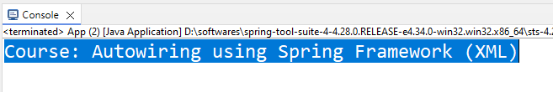
✔ XML autowiring successful
✔ No @Autowired used
Explanation:
XML autowiring injects dependencies through setter methods, not fields.

What happens in XML autowiring (byType)?
<bean id="student" class="com.klu.Student" autowire="byType"/>
Spring internally does:
- Creates Student object
- Looks for a setter method
- setCourse(Course course)
- Injects the matching Course bean
✔ If setter exists → Injection succeeds
❌ If setter does NOT exist → Injection fails

PART B: AUTOWIRING USING ANNOTATIONS

(SAME PROJECT)
👉 Now modify only configuration + add annotations
👉 No new project needed ❌

Modify Course.java (Add @Component)

---------------------------------------------------
package com.klu;

import org.springframework.stereotype.Component;

@Component
public class Course {

public String getCourseName() {
return "Spring Framework (Annotation)";
}
}

Modify Student.java (Add @Autowired)

---------------------------------------------------
package com.klu;

import org.springframework.beans.factory.annotation.Autowired;
import org.springframework.stereotype.Component;

@Component
public class Student {

@Autowired
private Course course;

public void display() {
System.out.println("Course: " + course.getCourseName());
}
}

Update applicationContext.xml (Enable Annotations)

-------------------------------------------------------------------
<beans xmlns="http://www.springframework.org/schema/beans"
xmlns:xsi="http://www.w3.org/2001/XMLSchema-instance"
xmlns:context="http://www.springframework.org/schema/context"
xsi:schemaLocation="
http://www.springframework.org/schema/beans
https://www.springframework.org/schema/beans/spring-beans.xsd
http://www.springframework.org/schema/context
https://www.springframework.org/schema/context/spring-context.xsd">

<!-- Enable annotation scanning -->
<context:component-scan base-package="com.klu"/>

</beans>
--------------------------------------------------------------------

NOTE: Remove <bean> definitions — annotations now control beans.

OUTPUT (ANNOTATION AUTOWIRING)
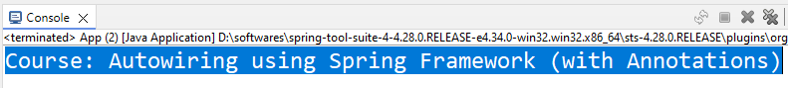
✔ @Component creates beans
✔ @Autowired injects dependency
✔ Same ApplicationContext

Aspect | XML Autowiring | Annotation Autowiring
Bean creation | <bean> tag | @Component
Dependency injection | autowire="byType" | @Autowired
XML size | Large | Very small
Setter required | ✅ Yes | ❌ No
Readability | Less | More
Industry usage | Legacy | Preferred
Explanation:
Without the following line, Spring will not recognize annotation-based configuration
https://www.springframework.org/schema/context/spring-context.xsd
Following line tells Spring: “Scan this package and create beans for classes with annotations.”
<context:component-scan base-package="com.klu"/>

